**PRACTICAL NO.8**

**Perform data visualization**

**a]Perform data visualization using Python on any sales data.**

**Code:**

import pandas as pd

import matplotlib.pyplot as plt

# Load the CSV file using pandas

data = pd.read_csv('mat_data.csv', parse_dates=['Date'])

# Display the first few rows of the data

print(data.head())

# to display multiple plots at once.figsize=(14, 10): This specifies the size of the overall figure in inches

fig, ax = plt.subplots(2, 2, figsize=(14, 10))

# Line Plot: Sales and Profit over Time

#marker='o'=to specify the shape of the markers that represent data points on a plot 'o':circle as the marker

ax[0, 0].plot(data['Date'], data['Sales'], label='Sales', color='b', marker='o')

ax[0, 0].plot(data['Date'], data['Profit'], label='Profit', color='g', marker='x')

ax[0, 0].set_title('Sales and Profit Over Time')

ax[0, 0].set_xlabel('Date')

ax[0, 0].set_ylabel('Amount')

ax[0, 0].legend()#A legend is used to label different plot elements (such as lines, markers, or bars)

# Bar Plot: Sales vs. Advertising

ax[0, 1].bar(data['Date'], data['Sales'], width=0.4, label='Sales', color='b', align='center')

ax[0, 1].bar(data['Date'], data['Advertising'], width=0.4, label='Advertising', color='orange', align='edge')

ax[0, 1].set_title('Sales vs Advertising')

ax[0, 1].set_xlabel('Date')

ax[0, 1].set_ylabel('Amount')

ax[0, 1].legend()

# Scatter Plot: Profit vs. Advertising

ax[1, 0].scatter(data['Advertising'], data['Profit'], color='r')

ax[1, 0].set_title('Profit vs Advertising')

ax[1, 0].set_xlabel('Advertising Spend')

ax[1, 0].set_ylabel('Profit')

# Histogram: Distribution of Sales

ax[1, 1].hist(data['Sales'], bins=5, edgecolor='black', color='skyblue')

ax[1, 1].set_title('Sales Distribution')

ax[1, 1].set_xlabel('Sales')

ax[1, 1].set_ylabel('Frequency')

# Adjust layout to prevent overlap

plt.tight_layout()

# Show the plots

plt.show()

**Output:**

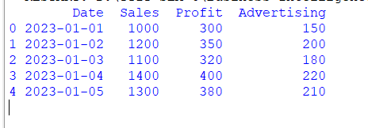

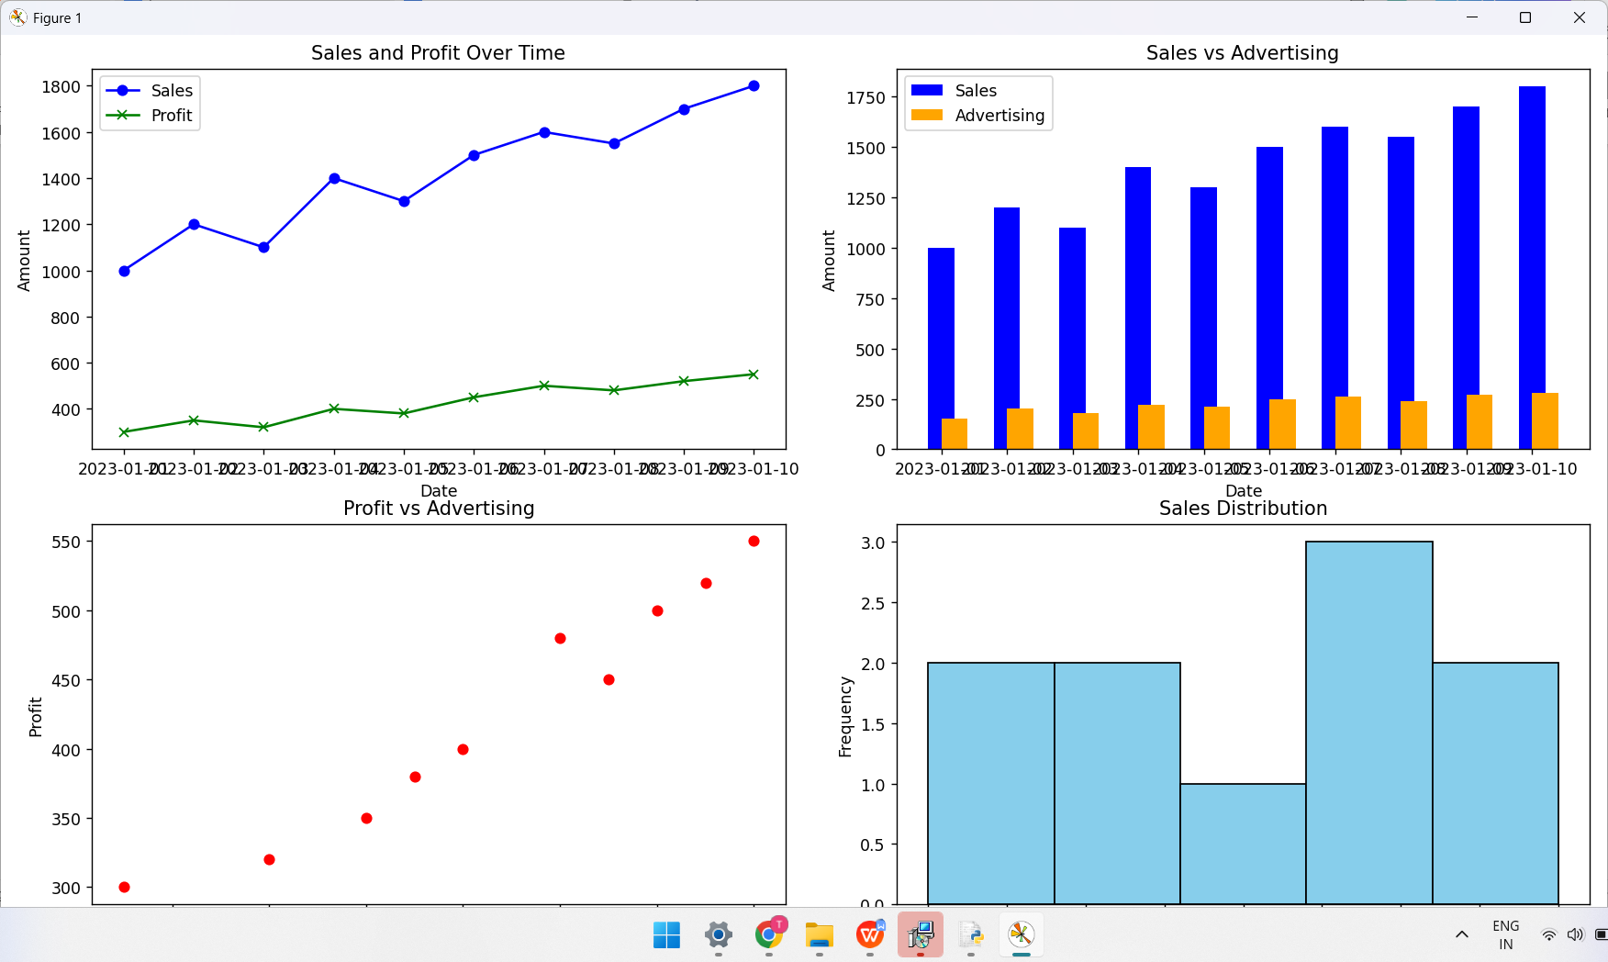

**b]Perform data visualization using PowerBI on any sales data :**

i] Open power BI:

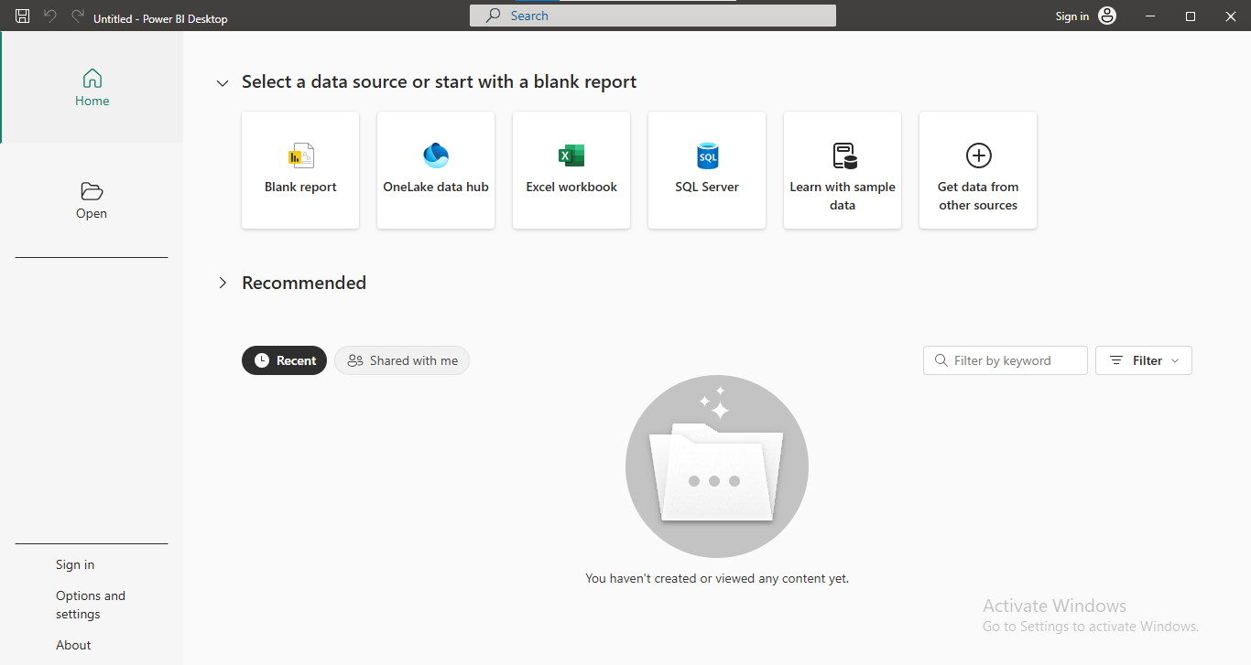

ii] Select the data file:

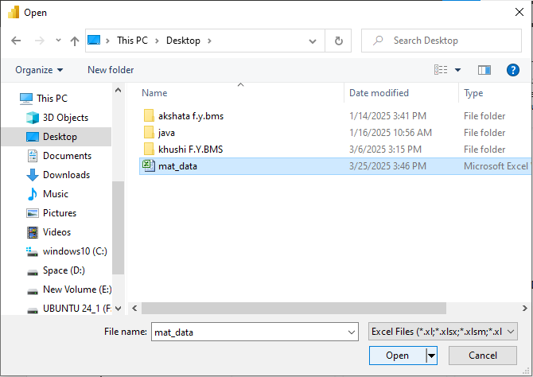

iii] Load the Data:

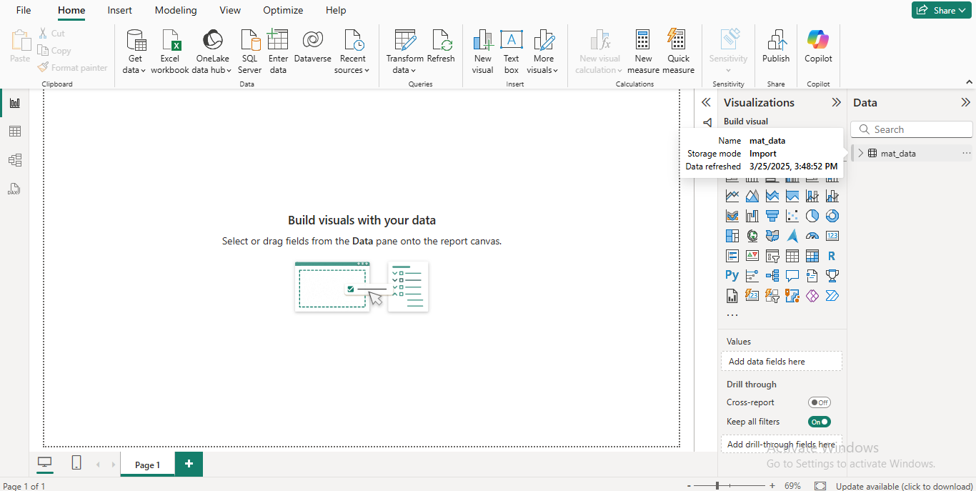

iv] Select the visualization option:

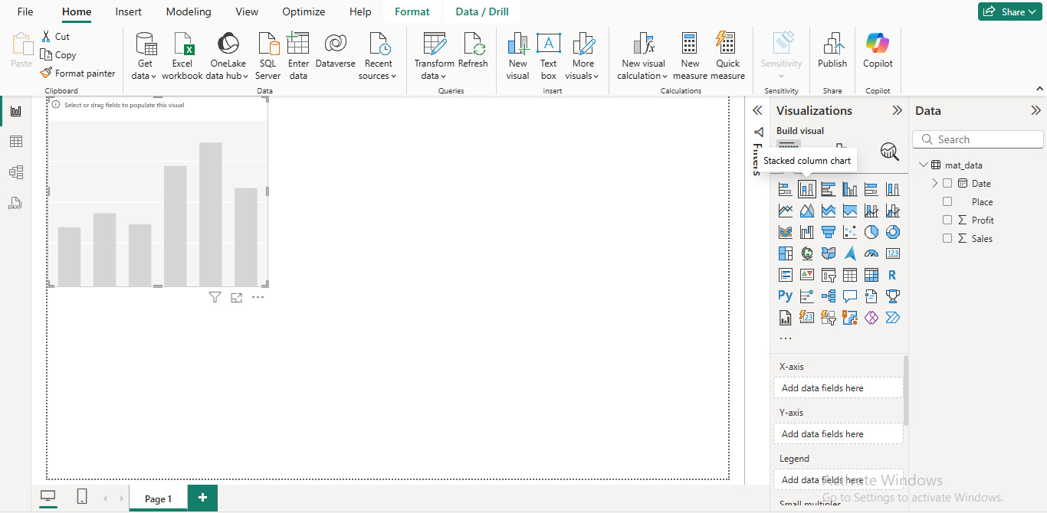

v] Select the fields and configure the component: For place and profit

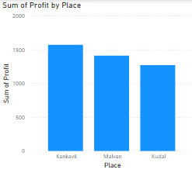

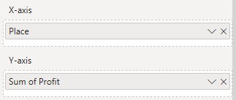

v] Select the fields and configure the component: For Sale according to date

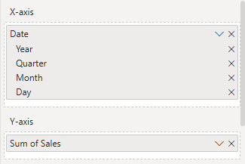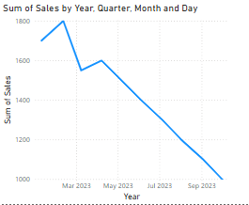

vi] Add some more appropriate graphs and then the final dashboard:

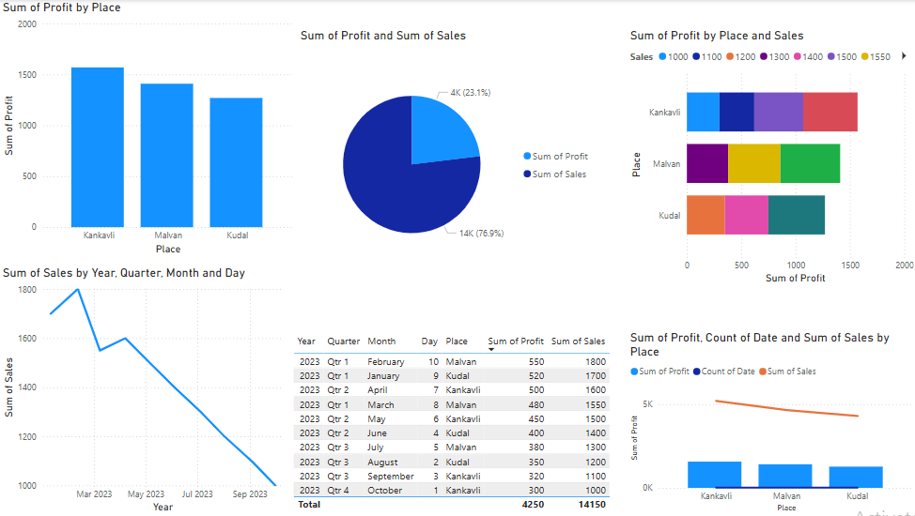

vii]Selection of a feature:

